**True Health Wellness (THW) Database Project Report**

**Abstract:**

True Health & Wellness Center provides a holistic approach to help patients improve their overall health: physical, mental, emotional, social, and spiritual. This company provides naturopathic medicine consulation, which includes functional labwork, naturopathic therapy, and an overall, natural care plan for a patient’s wellness concern.

This document describes the development of and presents any issues of this database project entitled “True Health Wellness”. I used MySQL Workbench to create the database and ER diagram. The Use Case diagram was made in a diagramming software, called draw.io. The database is built for the medical staff (receptionist, nurse, doctor) from the True Health & Wellness Center company. Patients are making appointments and/or ordering supplements using the company website. The medical staff maintains the appointments and supplements using this website, as well.

FYI: True Health & Wellness company is real and owned by a friend. However, data in some tables are fabricated, such that patients’ names are based on fictional characters and patients’ home addresses and phone numbers are based on theme park addresses and phone numbers, respectively.

**Mission Statement:**

The purpose of the THW database system is to maintain the data that is used and generated to support the naturopathic and holistic business for the patients and healthcare professionals, and to facilitate the cooperation and sharing of information between the private office and website.

**Mission Objectives:**

To maintain (enter, update, and delete) data on services

To maintain (enter, update, and delete) data on patients

To maintain (enter, update, and delete) data on staff

To maintain (enter, update, and delete) data on branches

To maintain (enter, update, and delete) data on bills

To maintain (enter, update, and delete) data on supplements

To perform searches on services

To perform searches on patients

To perform searches on staff

To perform searches on branches

To perform searches on bills

To perform searches on supplements

To report on services

To report on patients

To report on staff

To report on branches

To report on bills

To report on supplements

**ER Diagram**

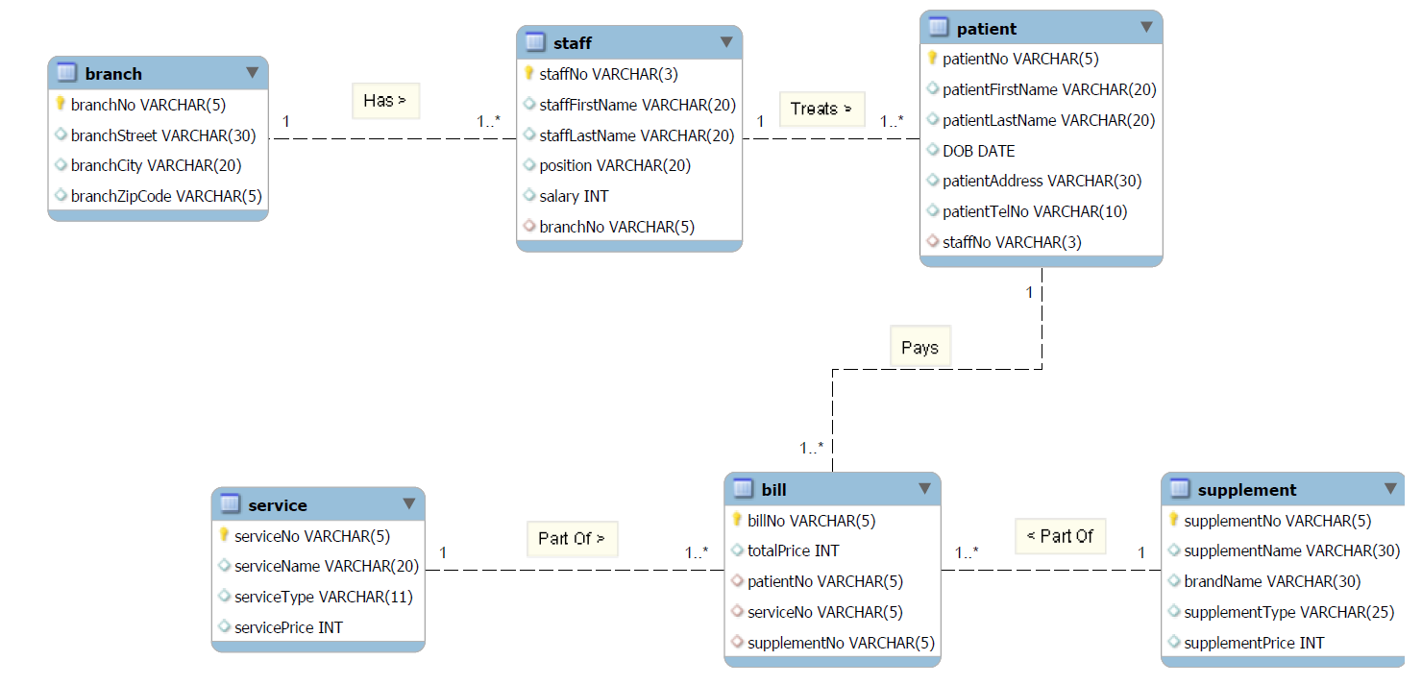

**Relation Schema**

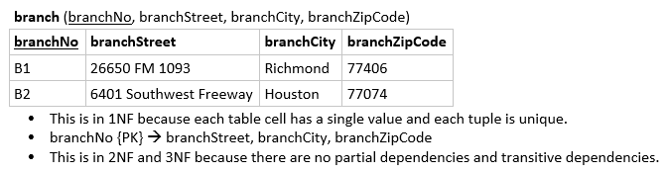

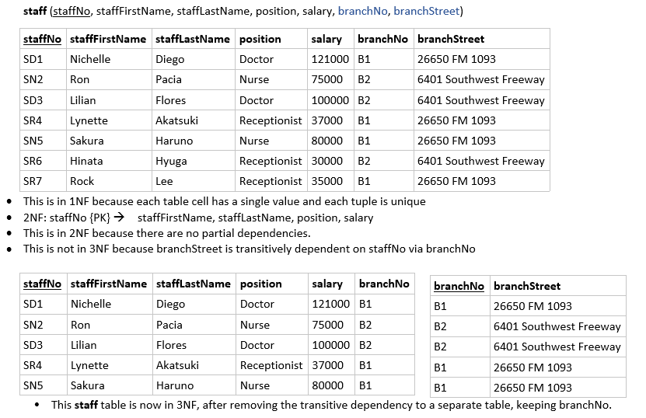

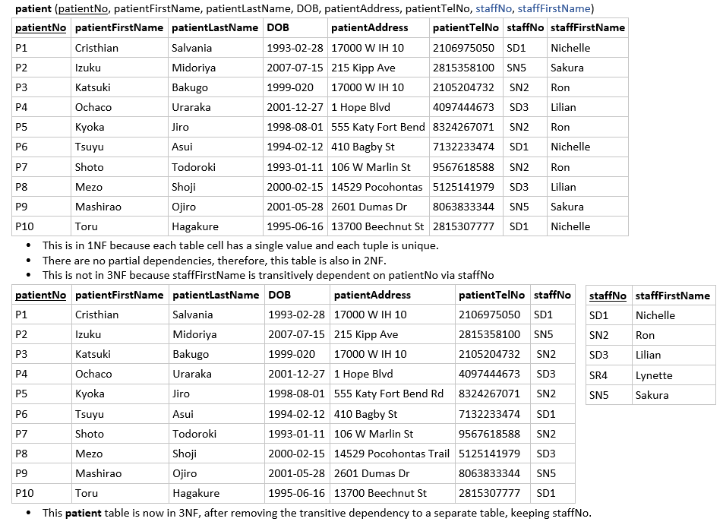

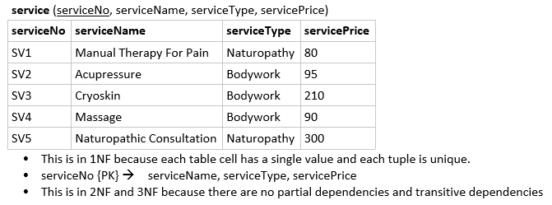

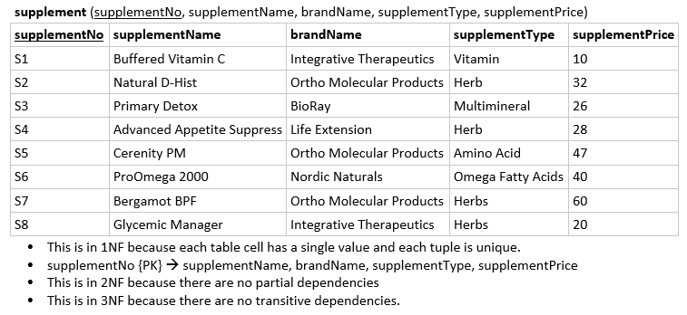

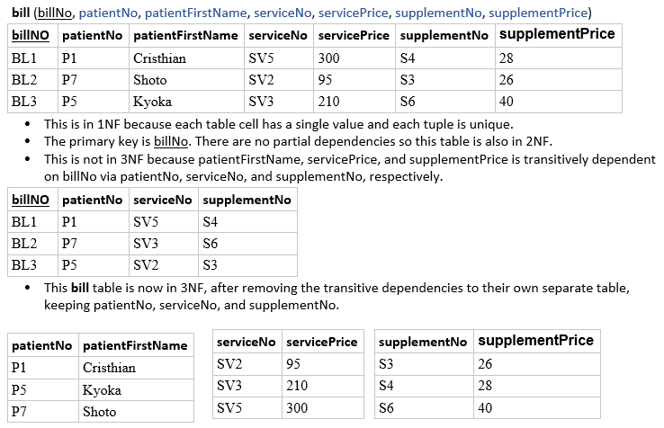

All 3NF tables are in my database and ER Diagram.

**Relational Schema After Normalization**

**branch** (branchNo, branchStreet, branchCity, branchZipCode)

**staff** (staffNo, staffFirstName, staffLastName, position, salary, branchNo)

**patient** (patientNo, patientFirstName, patientLastName, DOB, patientAddress, patientTelNo, staffNo)

**service** (serviceNo, serviceName, serviceType, servicePrice)

**supplement** (supplementNo, supplementName, brandName, supplementType, supplementPrice)

**bill** (billNo, patientNo, serviceNo, supplementNo)

**List of Use Cases:**

**Actor: Receptionist**

* Use Case Name: Login
  1. Actor enters login credentials (staff ID & password)
  2. Actor clicks **Log In**
* Use Case Name: Add New Patient
  1. Actor clicks on **New Patient**
  2. A new patient ID is shown
  3. Prompt to enter name, email, DOB, gender, home, and phone number
  4. All information is displayed, and system asks for confirmation.
  5. Actor clicks on **Confirm**
* Use Case Name: Maintain Patient Medical Records
  1. Actor clicks on **Patients**
  2. A list of patients is shown on screen
  3. Actor clicks on a patient’s name.
     + Patient name, DOB, home address, phone number, and their assigned staff are shown
     + Actor can enter, update, or delete above details or delete entire patient record
  4. Actor clicks **Save**
* Use Case Name: Maintain Supplements
  1. Actor clicks on **Supplements**
  2. A list of supplements is shown on screen
  3. Actor clicks on a supplement name
     + Supplement Name, Brand Name, Type, and Price are shown.
     + Actor can enter, update, or delete above details or delete entire supplement.
  4. Actor clicks **Save**

**Actor: Doctor/Nurse**

* Use Case Name: Login
  1. Actor enters login credentials (staff ID & password)
  2. Actor clicks on **Log In**
* Use Case Name: Update Patient Medical Records
  1. Actor clicks on **Patients**
  2. A list of patients is shown on screen
  3. Actor clicks on patient name
     + Patient number, name, DOB, home address, phone number, and their assigned staff are shown
     + Actor can view and edit above details
  4. Actor clicks **Save** to finish notes on patient’s medical record.
* Use Case Name: Add New Staff Member
  1. Actor clicks on **Employees** and **New Employee**
  2. A new staff ID is shown
  3. Prompt to enter name, DOB, gender, address, and phone number
  4. All information is displayed, and system asks for confirmation.
  5. Actor clicks on **Confirm**
* Use Case Name: Maintain Staff Records
  1. Actor clicks on **Employees**
  2. A list of employees is shown on screen
  3. Actor clicks on a staff name
     + Staff Number, Name, Position, Salary, and Branch Number are shown.
     + Actor can view, enter, update, or delete above details.
     + Actor clicks **Save** to finish editing on staff’s information.
* Use Case Name: Maintain Services
  1. Actor clicks on **Services**
  2. A list of services is shown on screen.
  3. Actor clicks on a service
     + Service Number, Name, Type, and Price are shown.
     + Actor can view, enter, update, or delete above details.
  4. Actor clicks on **Save**

**Actor: Patient**

* Use Case Name: Login
  1. Actor enters login credentials (email & password);
  2. Actor clicks on **Log In**
* Use Case Name: Pay Bills
  1. Actor clicks on **Billing & Payments**
  2. The current balance is displayed at the top of page followed by a list of recent services.
  3. To pay the entire balance, actor clicks **Pay Now**
  4. To pay a specific service, actor clicks to open service and clicks **Pay Now**
  5. Actor enters card information and clicks **Pay**.
* Use Case Name: Maintain Contact Info
  1. Actor clicks on **Settings > Modify Contact Info**
  2. The next page is displayed as a form with fields for First Name, Last Name, Address, and Phone Number.
  3. Actor clicks on a field to update information.
  4. Actor clicks **Save**

**

**Use Case Realization**

**Actor: Receptionist**

Use Case Name: Add New Patient

Register Jeanette Correa as a new patient:

**INSERT INTO** patient **VALUES** ('P11', 'Jeanette', 'Correa', '332 Prospect St.', '7162781794', 'SN2');

Use Case Name: Maintain Patient Medical Records

Change Ochaco Uraraka's to her new home address:

**UPDATE** patient

**SET** patientAddress = '123 Champagne Rd'

**WHERE** patientNo = 'P4';

Remove patient Jeanette from the system:

**DELETE FROM** patient

**WHERE** patientNo = 'P11';

Use Case Name: Maintain Supplements

Add new supplement to the system:

**INSERT INTO** supplement VALUES ('S9', 'Collagen Peptides', 'Vital Proteins', 'Amino Acid', 20);

Remove supplements of the Ortho Molecular Products brand

**DELETE FROM** supplement

**WHERE** brandName = 'Ortho Molecular Products';

Holiday Discount: All supplements get a 50% discount.

**UPDATE** supplement

**SET** supplementPrice = supplementPrice * .5;

**Actor: Doctor/Nurse**

Use Case Name: Add New Staff Member

Register Magda Cormier as a new employee:

**INSERT INTO** staff VALUES ('SN8', 'Magda', 'Cormier', 'Nurse', 75000, 'B2');

Use Case Name: Update Patient Medical Records

Reassign Toru to a different staff member:

**UPDATE** patient

**SET** staffNo = 'SN2'

**WHERE** patientNo = 'P10';

Remove patient Toru from the system:

**DELETE FROM** patient

**WHERE** patientFirstName = 'Toru';

Use Case Name: Maintain Staff Records

Promote Lynette to Nurse and raise her salary equal to Sakura's salary:

**UPDATE** staff

**SET** staffNo = 'SN4', position = 'Nurse', salary = 80000

**WHERE** staffNo = 'SR4';

Remove Magda from the system:

**DELETE FROM** staff

**WHERE** staffFirstName = 'Magda';

Use Case Name: Maintain Services

Add a new service:

**INSERT INTO** service **VALUES** ('SV6', 'Reiki Healing Energy', 'Naturopathy', 65);

Holiday Discount: 50% off on all services:

**UPDATE** service

**SET** servicePrice = servicePrice * .5;

Delete Reiki Healing Energy from the system:

**DELETE FROM** service

**WHERE** serviceName = 'Reiki Healing Energy';

Use Case Name: Add New Branches

Add new branch offices to the system:

**INSERT INTO** branch **VALUES** ('B3', '1716 Boswell St', 'Houston', '77009'),

('B4', '500 Houston St', 'Richmond', '77469'),

('B5', '15900 Southwest Fwy', 'Sugar Land', '77478');

**Actor: Patient**

Use Case Name: Pay Bills

Produce a bill or list of bills that Shoto owes:

**SELECT** b.billNo, p.patientFirstName, sv.serviceName, sv.servicePrice, s.supplementName, s.supplementPrice, sv.servicePrice + s.supplementPrice **AS** totalPrice

**FROM** bill b, service sv, supplement s, patient p

**WHERE** b.serviceNo = sv.serviceNo **AND** b.supplementNo = s.supplementNo **AND** b.patientNo = p.patientNo **AND** p.patientNo = 'P7';

Use Case Name: Maintain Contact Info

Change last name:

**UPDATE** patient

**SET** patientLastName = 'Mahogany'

**WHERE** patientFirstName = 'Mezo';

Use Case Name: Search Branch

Search for a branch located in Houston

**SELECT** * FROM branch

**WHERE** branchCity = 'Houston';

**Conclusion**

As stated in the abstract, this database project is based off of my friend's business, True Health & Wellness Center. I added more data to meet this project's criteria. I definitely should have created relationship types for Has (Branch Has Staff), Treats (Staff Treats Patient), and Pays (Patient Pays Bills), but I was not sure how to. However, I did create and execute JOIN statements for the relationship among Branch, Staff, and Patient and relationship among Patient, Bill, Service, and Supplement.

Video Demo:

<https://drive.google.com/file/d/1kk62i4XbFDw4Mc-rgeG0yH0om0uv9-KZ/view?usp=sharing>